**Malloc to alloca**

To replace malloc instruction to alloca, we need to go through all calls of malloc function and check whether it is freed ot no, after this we can replace instructions by *alloca* and remove *free* and *malloc* calls. The problem was appeared in replace instruction stage. Therefore, for now we need to find example of how to CreateAlloca of an array of pointers, also size check to prevent allocating huge memory on stack should be added.

Didn’t finish optimization because of the fail: “Assertion New->getType() == getType() && replaceAllUses of value with new value with different type”.

IR programs for checking correctness:

1. 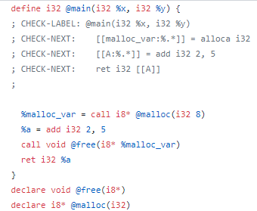
2. 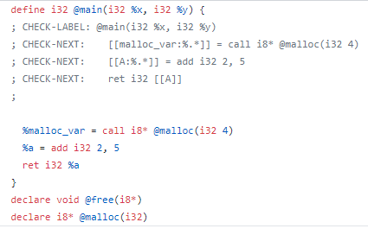
3. 